ASSIGNMENT 4
Student name: Pavithra P
Student register number: 2019504042
Maximum marks : 2
Question 1: write code and connections in wokwi for ultrasonic sensor where the distance is 100 cm and send alert to IBM cloud and display in the device recent events
Solution link: https://wokwi.com/projects/347687765305983570
Ibm cloud image:
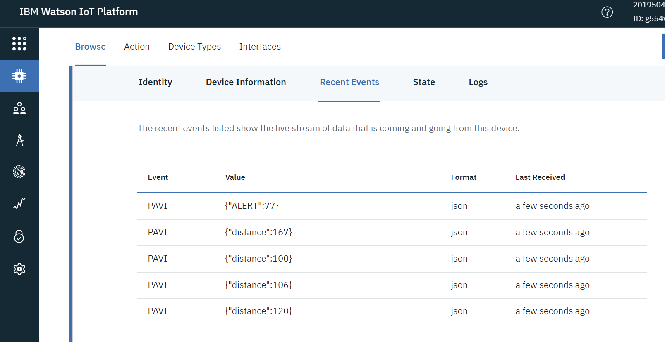

Simulatioimage:Ledoff:

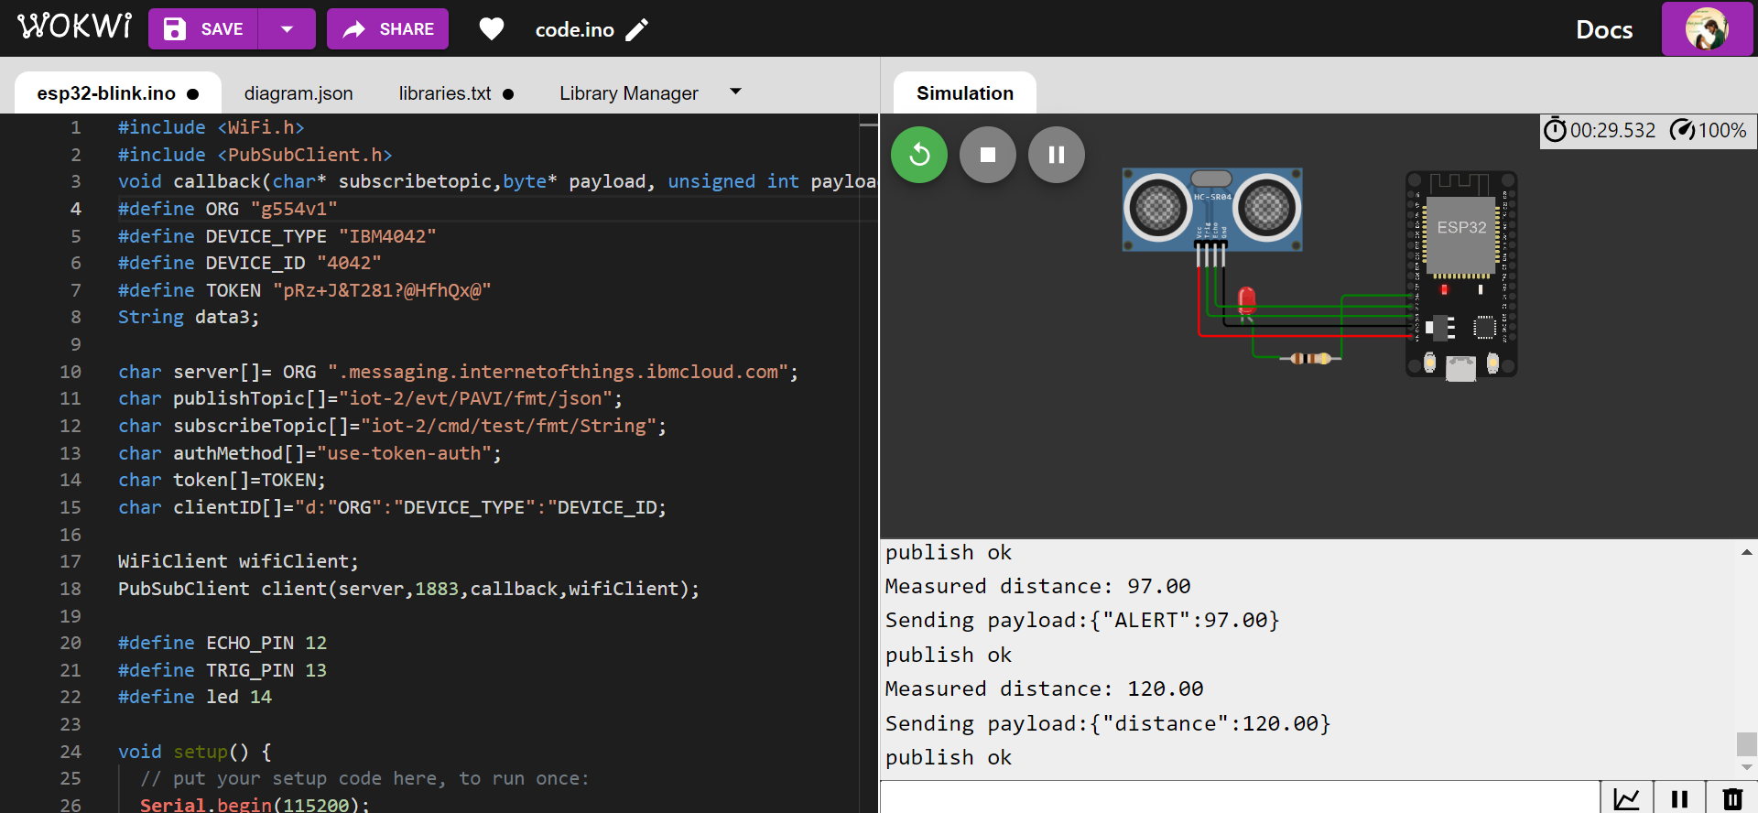
Led on:

